**Predicted Plots:**

After **Forecasting**, these plots can be predicted within a span of three years. And, it can be seen from the graphs that it would take 2023 to completely flatten the curve.Predicted Plots for the three successive years are plotted using the codes.

The **predicted plots** for confirmed, recovered and death cases are:-

**Predicted Death Cases’ Plot:**

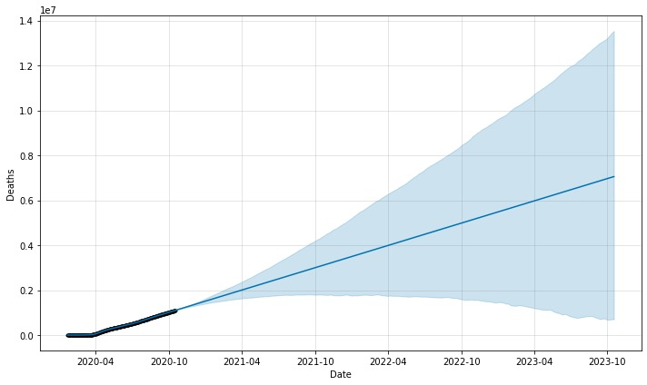

**Predicted Confirmed Cases’ Plot:**

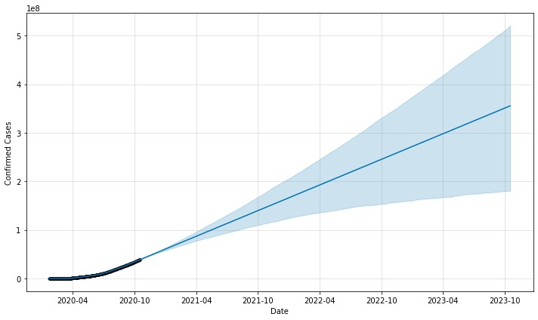

**Predicted Recovered Cases’ Plot:**

